A PROJECT REPORT

*Submitted by*

Utsav Kumar Singh [12203917]



*Under the supervision of*

Assistant prof. Bhawna Sharma

*At*

#### MASTER OF COMPUTER APPLICATION (SEMESTER-3)

LOVELY PROFESSIONAL UNKIVERSITY

JALANDHAR- DELHI, GRAND TRUCK RD, PHAGWARA

, PUNJAB- 144001

|  |  |  |  |
| --- | --- | --- | --- |
| **INDEX** | | | |
|  | | | |
|  | TABLE OF CONTENTS | | **Page No.** |
| a. | Acknowledgement | | i |
| b. | Abstract | | ii |
| c. | List of Figures | | iii |
| d. | List of Tables | | iv |
|  | | | |
| **1.** | **INTRODUCRTION** | | **1** |
|  | 1.1 | Project Summary | 2 |
|  | 1.2 | Purpose | 2 |
|  | 1.3 | Scope | 2 |
|  | 1.4 | Objective | 3 |
|  | 1.5 | Technology and Literature Review | 4 |
|  | | | |
| **2.** | **SOFTWARE PROJECT MANAGEMNT** | | 8 |
|  | 2.1 | Project Management | 9 |
|  | 2.1.1 | Project Development Approach | 9 |
|  | | | |
| **3.** | **SYSTEM REQUIREMENT STUDY** | | 20 |
|  | 3.1 | User Characteristics | 20 |
|  | 3.2 | Hardware and Software Requirements | 21 |
|  | 3.3 | Constraints | 21 |
|  | 3.3.1 | Hardware Limitations | 21 |

|  |  |  |  |
| --- | --- | --- | --- |
|  | 3.3.2 | Reliability Requirements | 21 |
|  | 3.3.3 | Safety & Security Considerations | 21 |
|  | 3.4 | Assumptions and Dependencies | 22 |
|  | 3.5 | Requirements of New System | 22 |
|  | 3.5.1 | Functional Requirements | 23 |
|  | 3.5.2 | Non Functional Requirements | 23 |
|  | | | |
| **4.** | **SYSTEM ANALYSIS** | | 24 |
|  | 4.1 | Structural Diagram | 25 |
|  | 4.2 | OOP Diagrams | 26 |
|  | 4.2.1 | Use case Diagram | 27 |
|  | 4.2.2 | Sequence Diagram | 28 |
|  | 4.2.3 | Activity Diagram | 29 |
|  | 4.4 | Data Dictionary | 30 |

### ACKNOWLEDGEMENT

I would like to thank my supervisor, Mrs. Bhawna Sharma for his guidance and comments on various aspects of this project and for thoughtful contribution in my effort.

I would also like to express my gratitude to the staff of Information Technology Department, Silver Oak College of Engineering & Technology for their co-operation.

I am also thankful to Silver Oak College of Engineering & Technology for providing me an opportunity to work in excellent working environment together with required resources.

Other known and unknown persons who helped me in my work also deserve thanks for their co-operation. Last but not the least; I am very thankful to my friends for providing me a valuable assistance during my work.

### ABSTRACT

This project *Driver Recruitment System (ERS)* is a system in which jobseekers can register themselves online, view organization requirements and apply for the suitable job. Driver Recruitment System provides online help to the users all over the world. This kind of system plays an important role in simplifying the recruitment process. The system has facilities where prospective candidates can upload their CV’s and apply for jobs suited to them. It also makes it possible for organization to post their staffing requirements and view profiles of interested candidates. Earlier recruitment was done manually and it was all at a time consuming work. Now it is all possible in a fraction of second. The system has been designed to do a whole lot more than just reduce paperwork. It can make a significant contribution to a company’s marketing and sales activities. Driver recruitment system make possible for managers to access information that is crucial to managing their staff, which they can use for human resources management, staffing and planning activities. The primary purpose to develop this system is to optimize the recruitment process for an organization. Besides, the qualified applicants could be sort by this system based on their qualifications and company requirements.

### LIST OF FIGURES

|  |  |  |
| --- | --- | --- |
| **Figure**  **No.** | **Title** | **Page**  **No**. |
| 2.1 | Incremental Model | 5 |

**LIST OF TABLES**

|  |  |  |
| --- | --- | --- |
| **Table No.** | **Title** | **Page No**. |
| 2.1 | Project Plan | 6 |
| 2.2 | Milestones And Deliverables | 7 |
| 2.3 | Roles And Responsibilities | 8 |

CHAPTER 1

INTRODUCTION

# Project Summary

* 1. Purpose

# Project Scope

* 1. Objective

# Technology And Literature Review

### Project Summary :

Driver Recruitment System by overall is aims to facilitate the applicant to apply for the job online. Indirectly, it is also to facilitate the managerial department of an organization for an optimized and systematic Driver recruitment process.

A quick look at the overall trends in Online recruiting shows the rise in the importance of recruiting on the web site, online training, dawn of video interviews and emergence of professional Internet Recruiters. Online recruiting systems, with its emphasis on a more strategic decision making process is fast gaining ground as a popular outsourced function.

The system also provides the global platform for both - jobseekers and the organization, where the jobseekers can find their dream jobs and organization can find the right candidate to fulfill staff requirements.

This system has web-forms like registration form, login form and account pages like user applicant page, admin account page etc. It includes following main modules:-

* Admin module
* Candidate module

An administrator can be a manager who has full authority over the whole system. The administrator is able to update and retrieve data from the account of candidate. The candidate is a center of this system. He has to register himself to use the services of the system.

### Purpose:

The primary purpose to develop this system is to optimize the recruitment process for an organization. Besides, the qualified applicants could be sort by this system based on their qualifications and company requirements.

The system has been designed to do a whole lot more than just reduce paperwork. It can make a significant contribution to a company’s marketing and sales activities.

### Project Scope:

Online Recruitment System enables the users to have the typical recruitment facilities and features at their disposal. It resolves typical issues of manual staffing processes and activities into a controlled and closely monitored work flow in the architecture of the application. This multi platform solution brings in by default, the basic intelligence and immense possibilities for further extension of the application as required by the user. The system makes it simpler to share and manage the organization’s human resource requirements with higher efficiency and easiness. The objective of these websites is to serve as a common meeting ground for jobseekers and organization, both locally and globally. This kind of systems is specifically designed for organization to help in solving staffing problems and managing human resource department activities at high degree of optimization.

### Objectives:

* + - This software helps applicants to find suitable job within the organization and apply for that job easily.
    - The software helps in managing and viewing details of interested applicants for the administrator.
    - The system is capable of sorting and filtering best suitable candidates based on some criteria.
    - Company will not have to waste his time for finding right Driver at right post

### 1.4 TECHNOLOGY AND LITERATURE REVIEW

##### Introduction of PHP

PHP is a server side scripting language. PHP is just a platform on which you can create dynamic web application. It is initiative is broad-based and very grand. It is open source, which encompasses the languages and execution platform, plus extensive class libraries, providing rich built-in functionality.

##### An Overview of PHP

PHP is a server-side scripting language designed for web development but also used as a general-purpose programming language. PHP is now installed on more than 244 million websites and 2.1 million web servers. Originally created by Rasmus Lerdorf in 1995, the reference implementation of PHP is now produced by The PHP Group. While PHP originally stood for Personal Home Page, it now stands for PHP: Hypertext Preprocessor.

PHP code is interpreted by a web server with a PHP processor module, which generates the resulting web page: PHP commands can be embedded directly into an HTML source document rather than calling an external file to process data. It has also evolved to include a command-line interface capability and can be used in standalone graphical applications.

PHP is free software released under the PHP License. PHP can be deployed on most web servers and also as a standalone shell on almost every operating system and platform, free of charge.

##### MySQL

MySQL is the world's second most widely used open-source relational database management system (RDBMS). The SQL phrase stands for Structured Query Language.

The MySQL development project has made its source code available under the terms of the GNU General Public License, as well as under a variety of proprietary agreements.

MySQL is a popular choice of database for use in web applications, and is a central component of the widely used LAMP open source web application software stack (and other 'AMP' stacks).

### LAMP framework:

LAMP is an acronym for "Linux, Apache, MySQL, PHP”.

The exact combination of the software included in a LAMP stack is prone to variation, for example Apache web server can be replaced by some [other web server software.](http://en.wikipedia.org/wiki/Comparison_of_lightweight_web_servers) Though the original authors of these programs did not design them to work as a component of the LAMP stack, the development philosophy and tool sets are shared and were developed in close conjunction, so they work and scale very well together. The software combination has become popular because it is entirely [free and open-source](http://en.wikipedia.org/wiki/Free_and_open-source_software) [software,](http://en.wikipedia.org/wiki/Free_and_open-source_software) which means that each component can be adapted to the underlying hardware and customized to meet the specification as exactly as possible, without the slightest [vendor lock-in.](http://en.wikipedia.org/wiki/Vendor_lock-in) The complete software stack is also free of cost, maximizing the available budget for tailoring the hardware and software.

Due to the nature of free and open-source software and the ubiquity of its components, each component of the LAMP stack is very well tested regarding performance and security. At the same time, there is an abundance of experienced contractors to do the tailoring required for various customizations, or for complex setups. There is also constant development going on.

### Introduction to XAMPP :

XAMPP requires only one zip, tar, [7z](http://en.wikipedia.org/wiki/7z), or [exe](http://en.wikipedia.org/wiki/EXE) file to be downloaded and run, and little or no configuration of the various components that make up the web server is required. XAMPP is regularly updated to incorporate the latest releases of [Apache,](http://en.wikipedia.org/wiki/Apache_HTTP_Server) [MySQL,](http://en.wikipedia.org/wiki/MySQL) [PHP](http://en.wikipedia.org/wiki/PHP) and [Perl](http://en.wikipedia.org/wiki/Perl). It also comes with a number of other modules including [OpenSSL](http://en.wikipedia.org/wiki/OpenSSL) and [phpMyAdmin.](http://en.wikipedia.org/wiki/PhpMyAdmin)

Self-contained, multiple instances of XAMPP can exist on a single computer, and any given instance can be copied from one computer to another.

It is offered in both a full, standard version and a smaller version.

**APACHE HTTP Server:**

The Apache HTTP Server, commonly referred to as Apache is a [web server](http://en.wikipedia.org/wiki/Web_server) application notable for playing a key role in the initial growth of the [World Wide Web](http://en.wikipedia.org/wiki/World_Wide_Web). Originally based on the NCSA HTTPd server, development of Apache began in early 1995 after work on the NCSA code stalled. Apache quickly overtook NCSA HTTPd as the dominant HTTP server, and has remained the most popular HTTP server in use since April 1996. In 2009, it became the first web server software to serve more than 100 million websites.

Apache is developed and maintained by an open community of developers under the auspices of the [Apache Software Foundation](http://en.wikipedia.org/wiki/Apache_Software_Foundation). Most commonly used on a [Unix-](http://en.wikipedia.org/wiki/Unix-like) [like](http://en.wikipedia.org/wiki/Unix-like) system, the software is available for a wide variety of [operating systems,](http://en.wikipedia.org/wiki/Operating_system) including [Unix](http://en.wikipedia.org/wiki/Unix)[,FreeBSD](http://en.wikipedia.org/wiki/FreeBSD), [Linux](http://en.wikipedia.org/wiki/Linux), [Solaris](http://en.wikipedia.org/wiki/Solaris_(operating_system)), [Novell NetWare](http://en.wikipedia.org/wiki/Novell_NetWare), [OS X](http://en.wikipedia.org/wiki/OS_X), [Microsoft](http://en.wikipedia.org/wiki/Microsoft_Windows) [Windows](http://en.wikipedia.org/wiki/Microsoft_Windows), [OS/2](http://en.wikipedia.org/wiki/OS/2), [TPF](http://en.wikipedia.org/wiki/Transaction_Processing_Facility), [OpenVMS](http://en.wikipedia.org/wiki/OpenVMS) and [eComStation](http://en.wikipedia.org/wiki/EComStation). Released under the[Apache License](http://en.wikipedia.org/wiki/Apache_License), Apache is [open-source software.](http://en.wikipedia.org/wiki/Open-source_software)

### Key Features:

Apache supports a variety of features, many implemented as [compiled](http://en.wikipedia.org/wiki/Compiler) [modules](http://en.wikipedia.org/wiki/Modular_programming) which extend the core functionality. These can range from server-side programming language support to authentication schemes. Some common language interfaces support [Perl](http://en.wikipedia.org/wiki/Mod_perl), [Python,](http://en.wikipedia.org/wiki/Mod_python) [Tcl](http://en.wikipedia.org/wiki/Tcl), and [PHP](http://en.wikipedia.org/wiki/PHP). Popular authentication modules include mod_access, mod_auth, mod_digest, and mod_auth_digest, the successor to mod_digest. A sample of other features include [Secure Sockets Layer](http://en.wikipedia.org/wiki/Secure_Sockets_Layer) and [Transport Layer Security](http://en.wikipedia.org/wiki/Transport_Layer_Security) support ([mod_ssl](http://en.wikipedia.org/wiki/Mod_ssl)), a[proxy](http://en.wikipedia.org/wiki/Proxy_server) module ([mod_proxy](http://en.wikipedia.org/wiki/Mod_proxy)), a [URL rewriter](http://en.wikipedia.org/wiki/URL_rewriting) (mod_rewrite), custom log files (mod_log_config), and filtering support (mod_include and mod_ext_filter).

Popular compression methods on Apache include the external extension module, mod_gzip, implemented to help with reduction of the size (weight) of web pages served over[HTTP.](http://en.wikipedia.org/wiki/HTTP) [ModSecurity](http://en.wikipedia.org/wiki/ModSecurity) is an open source intrusion detection and prevention engine for web applications. Apache logs can be analyzed through a web browser using free scripts such as [AWStats](http://en.wikipedia.org/wiki/AWStats)/[W3Perl](http://en.wikipedia.org/wiki/W3Perl) or [Visitors](http://en.wikipedia.org/w/index.php?title=Visitors_(program)&action=edit&redlink=1).

Apache features configurable error messages, [DBMS](http://en.wikipedia.org/wiki/Database_management_system)-based authentication databases, and [content negotiation.](http://en.wikipedia.org/wiki/Content_negotiation) It is also supported by several [graphical user interfaces](http://en.wikipedia.org/wiki/Graphical_user_interface) (GUIs).

It supports password authentication and [digital certificate](http://en.wikipedia.org/wiki/Digital_certificate) authentication. Because the source code is freely available, anyone can adapt the server for specific needs, and there is a large public library of Apache add-ons.

CHAPTER 2

PROJECT MANAGEMENT

# Project Planning

# Project development approach

##### PROJECT PLANNING

Project planning includes description of the project task, activity and function, dependencies, resource requirements and detail schedules. Project planning involves estimating how much time, efforts, money and resources will be required build a specific software system.

##### Project Development Approach and Justification

A Software Process model is simplified abstract representation of a software process, which is presented from a particular perspective. Planning prepares a framework that makes a reasonable estimate of the project. To accomplish it, software development models are used. Incremental model is used to satisfy this purpose.

##### Incremental Model:

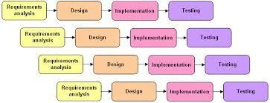

**FIGURE 2.1 : Incremental Model**

The system uses this method of software development where the model is analyzed, designed, tested and implemented. In incremental model, system is developed in various units. These units entail the requirement planning, development and test phases. This

module is useful for big and small products. It is divided into units. It satisfies the customer’s needs.

The Incremental Model combines elements of the linear sequential model with the iterative philosophy of prototyping. The incremental model applies linear sequences in a staged fashion as calendar time progresses. Each linear sequence produces a deliverable “increment” of the software. In incremental model first increment is called core product. In core product basic requirements are added but some unknown supplementary features remains undelivered. This core product is used by customer to evolutes the system and next increment is planned to develop.

During first increment analysis phase, customer and developers specifies as many requirements as possible and prepare documentation. Now a first version of product with minimal and essential feature is launched to market. Based on the feedback and experience with this version, list of additional features are added. This process is repeated following the delivery of each increment, until the complete product is produced.

With this approach first model may be available within few weeks or months. In this model, less cost and time is required to develop first increment called core product. Less risk is occurred to develop the smaller systems represented by the increments. Incremental funding is allowed, means only one or two increments might be funded when the program starts. It can results in better testing, because testing each increment is likely to be easier than testing entire system. The feedback providing at each increment is useful for determining the final requirement of system.

CHAPTER 3

SYSTEM REQUIREMENTS STUDY

## User Characteristics

* 1. Hardware and Software Requirement Specification

## Constraints

* 1. Assumptions and Dependency

## Requirements of New System

### USER CHARACTERISTICS:

Three types of user interact with the system:

##### COMPANY (HR Department):

The following are the acts performed by the HR department of company throughout the system:

* + Project Management
  + Contact Management
  + Team Member and Team Management
  + Partner Management
  + Data Management
  + Activity Management
  + Feedback Management

##### ADMINISTRATOR:

Admin can update, delete, modify the detail of the candidates which are filled by them only of their respective department..He also can schedule examination activities and sort candidates basis on exam results.

##### JOBSEEKER:

Jobseeker can register himself, upload CVs, find the appropriate job within organization’s vacancy constraints, attend the exam and give feedback about the system.

### HARDWARE AND SOFTWARE REQUIREMENT SPECIFICATION

##### Server Side:

**Hardware**

* + - Processor : Intel core processor 2 GHz
    - RAM : 2 GB RAM
    - Hard Disk : 80 GB HDD
    - Monitor : Compatible Printing Device
    - Keyboard : Any Keyboard

•

##### Software

* + - Operating System : Microsoft Windows 7/8/8.1/XP/VISTA
    - Package : Adobe Dreamweaver
    - Database : MY SQL
    - Diagram : Microsoft Office Visio 2003
    - Design : Adobe Photoshop CS6.0 , Micromedia Flash Player
    - Browser : IE (Version 6 or higher) , Mozila Firefox or Google Chrome

##### Client side:

**Hardware**

* + - Processor : Intel core i3 or higher processor 2 GHz
    - RAM : 520 MB RAM
    - Hard Disk : 40 GB HDD
    - Monitor : Compatible Printing Device
    - Keyboard : Any Keyboard

##### Software

* + - APACHE Server
    - MYSQL Server
    - IE (Version 6 or higher)

### CONSTRAINTS:

##### Hardware Limitations

The limitation of dream viewer is that it requires RAM that cannot be less than 520 MB and the processor cannot be less than 2 GHz speed as recommended in the hardware requirements.

##### Reliability Requirements

The main reliability requirement is the validation used. Without proper validation the system does not allow to enter that value into database. All the required validation controls are kept controls are kept to keep the system secure.

The following are the some of the reliability requirements:

* + - * In the email ID the user cannot enter any dummy value, the validation checks that whether there is a '@' or '_' symbol in that.
      * Any null value is not allowed in place of compulsory fields.
      * In numeric field user cannot enter any character value.
      * In date of birth, user cannot enter date and time other than given format
      * Entered password and confirm password must match to each other.
      * User can not re –register an account on his primary email.

##### Safety and Security Considerations Safety:

The source of this software will be kept at more than one place with user ID, password and also in CD ROM in case of server failure.

##### Security:

Security in this software provide to different user in different ways by giving different user id. If user is admin, he has all the privileges and constraints. He can access the entire database. He can change or delete database from other user’s accounts. HR department have limited access according to their role. Because of limited privileges one of them cannot update other details of the candidate.

### Assumption and Dependencies:

* + - End user is the person having enough knowledge for the project operation.
    - Only admin have all the privileges.
    - Candidate can only fill the registration form.
    - Candidate cannot apply for job after deadlines.

### REQUIREMENTS of A NEW SYSTEM:

* + 1. **Functional requirements:**
       - The system should record all the details of an applicant.
       - The system should provide applicant to edit his profile details.
       - The system should allow user to give feedback about the system.
       - The system should have the facility of administrative help for user to solve his important problems.
       - The system should allow admin to have full authority over user accounts.
       - The system should allow admin to display vacancy within thw organization.
       - The system should allow admin to sort and filter applicants based on some criteria.
       - The system should allow admin to send notifications about upcoming events and deadlines to applicants.
       - Username & password are sent to the users via mobile sms and email after registration.
       - Password recovery system is also provided in case of forgetting the password.

### Non functional requirements:

* + - * This application is secure for every kind of its users, because here is facility of session management. If any user logout from any session then nobody will be able to access his profile without knowing his confidential password.
      * The database used here is robust, reliable & fast. So users will have to wait for the output very short time.
      * This application can be accessed from any type of platform.
      * There is no case of redundancy in the database so it will not take extra memory space.

.

CHAPTER 4

SYSTEM ANALYSIS

# Structural Diagram

* 1. OOPS Diagrams

# Data Dictionary

### Structural Diagram

Candidate Module

Admin Module

Ask for help from admin

View feedback and help

Give feedback

Update requirement statistics

View vacancy details

Filter candidates on criteria

Update profile details

Update candidate’s detail

Apply for the job

Employee Recruitment System

* 1. **OOPS DIAGRAMS**

### Use Case Diagram.

Use case diagrams are behavior diagrams used to describe a set of actions (use cases) that some system or systems (subject) should or can perform in collaboration with one or more external users of the system (actors). Each use case should provide some observable and valuable result to the actors or other stakeholders of the system.

### Sequence Diagram

A sequence diagram is a kind of interaction diagram that shows how processes operate with one another and in what order. It is a construct of a Message Sequence Chart. A sequence diagram shows object interactions arranged in time sequence. It depicts the objects and classes involved in the scenario and the sequence of messages exchanged between the objects needed to carry out the functionality of the scenario. Sequence diagrams are typically associated with use case realizations in the Logical View of the system under development. Sequence diagrams are sometimes called event diagrams, event scenarios

### Activity Diagram

Activity diagrams are the object-oriented equivalent of flow charts and data-flow diagrams from structured development. It describes the workflow behavior of a system. The process flows in the system are captured in the activity diagram. Activity diagram illustrates the dynamic nature of a system by modeling the flow of control from Activity to activity.

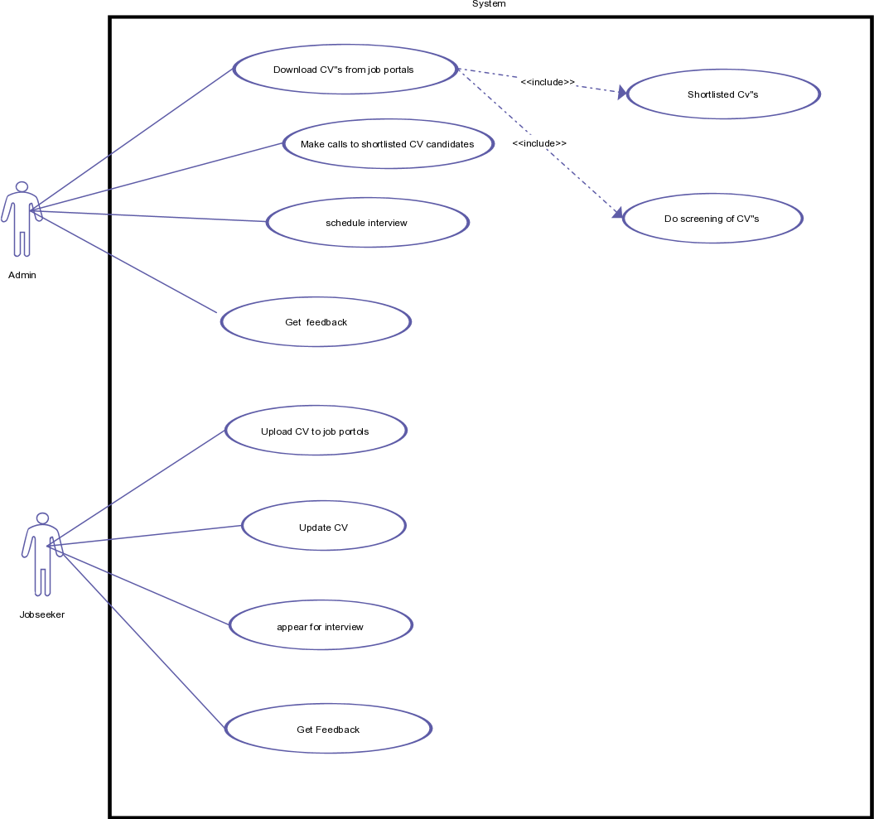

Filter applicants

Update Requirements

Update profile

View requirement statistics

##### Use Case Diagram

mnbbbb

### Data Dictionary

* Data Dictionary is catalog – a repository of the elements in the systems.
* This element centre data and way they are structure to meet user requirements and organization needs.
* Data Dictionary contains list of all elements composing the following through a system.
* The major element of data flow, data stores and processes.
* The Data Dictionary stores details and description of this element.

#### Need of Data Dictionary:

* To manage details in a large system.
* To communicate a common meaning for all system elements.
* To document the futures of the system.
* To facilitate analysis of the details in order to evaluate characteristics and to determine where system should be made.
* To locate errors and omission in the system.

### Table: Personal Details

|  |  |  |  |  |
| --- | --- | --- | --- | --- |
| **Field** | **Data Type** | **Size** | **Constraints** | **Description** |
| User id | int | 100 | Primary Key  Auto Increment | It is the unique  id of user. |
| First name | varchar | 255 |  | First name of  user |
| Middle name | varchar | 255 |  | Middle name of  user |
| Last name | varchar | 255 |  | last name of  user |
| Gender | varchar | 255 |  | Male/female |
| Birth date | date |  |  | Date of birth of  user |
| state | varchar | 255 |  | Current state of  user |
| city | varchar | 255 |  | Current city of  user |

**Table: Academic Details**

|  |  |  |  |  |
| --- | --- | --- | --- | --- |
| **Field** | **Data Type** | **Size** | **Constraints** | **Description** |
| User id | int | 100 | Primary Key Auto Increment Foreign key | It is the unique id of user. |
| university | varchar | 255 |  | University of user |
| institute | varchar | 255 |  | Institute of user |
| branch | varchar | 255 |  | Branch in which studying/studied |
| degree | varchar | 255 |  | BE/B.TECH/ ME/M.TECH/ BBA/MBA |
| status | varchar |  |  | Pursuing / Completed |
| CPI | float | 255 |  | CPI or grade achieved |
| semester | int | 255 |  | (If pursuing) – current semester |
| experience | int | 255 |  | (If completed) - experience |

### Table: Account Details

|  |  |  |  |  |
| --- | --- | --- | --- | --- |
| **Field** | **Data Type** | **Size** | **Constraints** | **Description** |
| User id | int | 100 | Primary Key Auto Increment Foreign key | It is the unique id of user. |
| Post | varchar | 255 |  | Post for which user is applying |
| Primary email | varchar | 255 | Unique key | Primary email – will be used for  login |
| Secondary email | varchar | 255 | Unique key | Secondary email – can be  used for account recovery |
| Password | varchar | 255 |  | Password defined by user |

**Table: Admin Details**

|  |  |  |  |  |
| --- | --- | --- | --- | --- |
| **Field** | **Data Type** | **Size** | **Constraint** | **Description** |
| Admin id | int | 100 | Primary Key | It is the unique  id of admin. |
| email | varchar | 255 | Unique key | email – will be  used for login |
| password | int | 255 |  | Password defined by  admin |

### Table: Requirement Statistics

|  |  |  |  |  |
| --- | --- | --- | --- | --- |
| **Field** | **Data Type** | **Size** | **Constraints** | **Description** |
| Post name | varchar | 255 |  | Post available in organization |
| vacancies | int | 255 |  | Vacancy for particular post within the  company |
| Required experience | int | 255 |  | Required minimum experience to  apply for the job |
| Min salary | int | 255 |  | Minimum salary  for particular post |
| Max salary | int | 255 |  | Maximum salary for particular post |

